Energy Storage Options in Conjunction with Nuclear Power Generation
Carly Romnes
University of Illinois at Urbana-Champaign
cromnes2@illinois.edu

Abstract
Around the world, there is increasing interest in a carbon-free economy which will require greater use of carbon-free or low-carbon energy sources and energy storage systems. To achieve a carbon-free economy, there is a need to increase flexibility of the grid but also address issues with intermittent renewable energy. Nuclear energy in conjunction with energy storage systems will be an invaluable asset to increase grid flexibility and ensure consistent and reliable energy generation. Various energy storage options can be implemented with nuclear power generation depending on the reactor design and where the system is being built. Viable energy storage options that can be used in conjunction with nuclear power generation are described in this report, as well as their potential to not only promote the use of nuclear energy but also renewable energy. All clean energy storage and energy generation options should be implemented to decrease emissions and ensure future energy demands are met.

Introduction
As more utilities, cities, and states adopt goals of having net-zero carbon emissions by 2050, there is a greater need for implementing more carbon-free energy systems. The recent announcement of new goals for fighting climate change further advances this need. As we strive to reduce our emissions, nuclear energy will be essential to achieve our goal of carbon-free energy generation and a carbon-free economy.
There are many benefits to implementing greater use of nuclear energy. Nuclear power is a clean source of energy that can act as a great compliment to renewable energy sources. Nuclear energy is consistent and reliable, with current capacity factors reaching 90% or greater.¹ Due to this reliability, nuclear energy is currently used for base-load energy supply, but we need to find ways increase our use of nuclear energy. Nuclear power systems can also be effectively integrated with renewable energy systems, these systems are called Nuclear-Renewable Hybrid Energy Systems (N-R HES), and they could be the future of our electrical grid.²
Beyond the use of nuclear energy, nuclear technology has many applications that extend beyond low-carbon energy production, and these uses should be recognized to further support nuclear related research. Nuclear technology can be used to help control the spread of disease, assists doctors in diagnosing and treating patients, and can be used to power complicated missions and space exploration.³ Nuclear technology supports disease detection, imaging, prevention, and vaccine development.⁴ These varied uses should position nuclear technologies at the heart of the world’s efforts to achieve sustainable development, but unfortunately this is not true. There is some stigma against nuclear energy, particularly due to the issues created by weapons programs and previous nuclear power accidents that have occurred in other countries as well as in the USA.
Besides this stigma against nuclear energy, there are other issues with implementing nuclear power on a large scale. One major issue is the high capital costs to implement current nuclear designs. Even the next generation of nuclear reactor designs can be fairly expensive to build. These high capital costs are further complicated by cheap natural gas driving down energy prices; market liberalization allowing fossil fuels to undercut renewables; over-subsidy of renewable energy sources without offering the same subsidies to nuclear power plants; and political campaigning.^{1,3} The cost of natural gas has allowed it to essentially be the replacement of coal, as can be seen in Figure 1 below. We need to stop this trend and promote renewable energy as a good alternative to these fossil fuels. The subsidies for renewable energy sources allow these companies to compete with the cheap energy prices imposed by fossil fuels, but not offering the same subsidies to nuclear plants results in the nuclear energy produced being sold at cost or at a loss, making it extremely difficult to debunk the high capital costs. Essentially, the result is nuclear energy providers are hemorrhaging money and do not have the same support that renewable energy sources have to keep going.¹ Several things must be done to address these issues, but beyond activism and changing policies, we need to determine ways to reduce the capital costs of nuclear power plants, and energy storage could be a very helpful factor to reduce these costs.
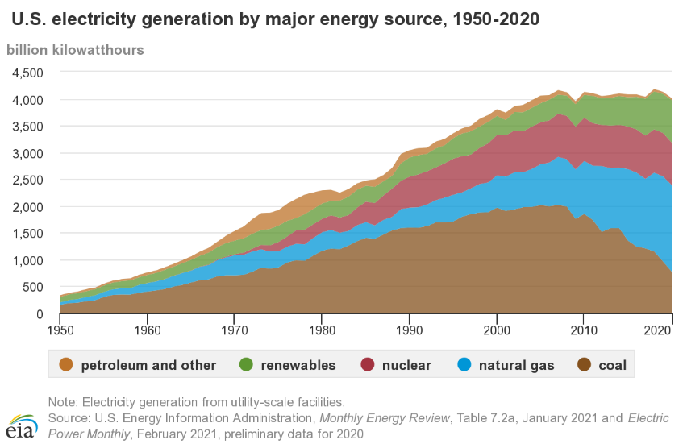
Figure 1. How electricity generation has changed in the USA has changed over time.⁵
As can be seen in Figure 2 below, nuclear energy has provided a fairly consistent amount of our power throughout the years, approximately 20%, even as more nuclear power plants are being shut down than are being built. The US currently has 94 operational nuclear reactors, with 2 new reactors being built. Over the past several years, 39 nuclear reactors have shut down, and we have not replaced these systems. Many of these reactors shut down early and were licensed to operate for many more years. For example, Excelon recently announced that it would be shutting down four reactors in Illinois, their Byron and Dresden plants.¹ They also announced that there was a high possibility of shutting down four more reactors at two of their other sites. The reason for these early retirements are cheap natural gas and declining energy prices, which makes it hard for nuclear energy and renewables to compete without subsidies or carbon emission taxes.¹ To break this trend, we need to implement energy storage in conjunction with nuclear energy and we need to start building new reactor designs.
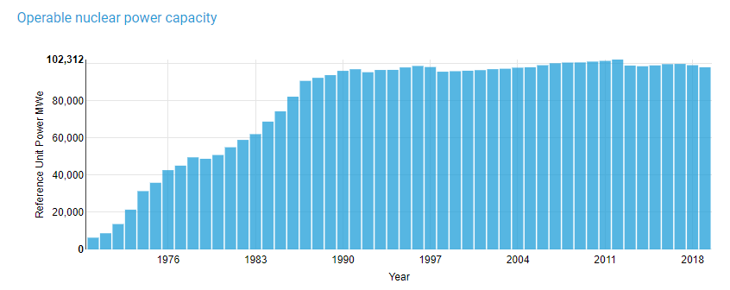
Figure 2. Electricity generated by nuclear power in the USA.¹
When we discuss our energy needs, we tend to focus on electricity generation. Figure 3a below shows our sources of energy generation, where ~40% of our electricity comes from carbon-free sources. When the actual energy consumption across all areas is discussed, this percentage is much lower, ~19%, due to the high use of petroleum, see Figure 3b. The high use of petroleum can be addressed by implementing more electric vehicles, but this will increase the current energy demands. This increased demand promotes the need for energy sources that are consistent but flexible, as well as the need for energy storage. Overall, there is a need to increase the amount of energy that comes from consistent, zero-carbon energy sources, with increased flexibility. Nuclear energy in conjunction with energy storage and load following options can fulfill this need.
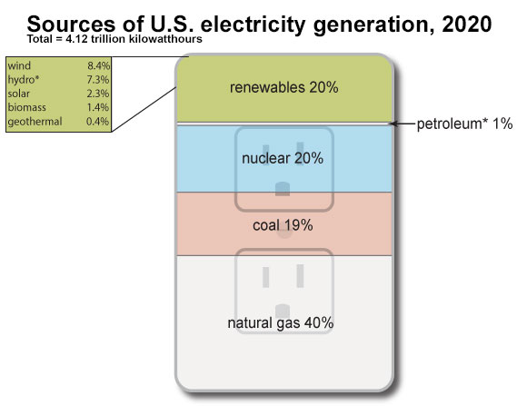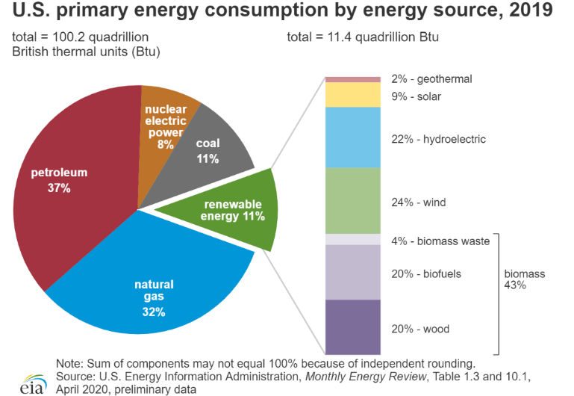
a.
b.
Figure 3.a. Sources of electricity in the US in 2020 ⁵. b. Energy consumption by source in the US in 2019.⁶

Types of Nuclear Reactor Designs and Concepts
Currently, the nuclear reactor designs in the USA are not load following, which inhibits the widespread use of nuclear since these plants are designed to output a consistent amount of power. Load following is not cost competitive for light water reactors, particularly due to the fact that the decreased energy production would make it harder for these reactors to overcome the capital costs of building the power plant. In France, nuclear reactors are load following and this allows France to obtain a greater amount of its electricity from nuclear energy, ~71% of France’s energy comes from nuclear power.³ Since many current designs complicate load following, we can essentially implement load following with energy storage, an example of this is in Figure 4 below. Implementing nuclear power systems with energy storage could allow nuclear to provide a larger percentage of our energy and help eliminate the need for coal and natural gas powered plants. Greater use of energy storage systems would not only promote nuclear energy, it would also promote the use of wind and solar power and hybrid systems, N-R HESs, by helping reduce the intermittency issues associated with these energy sources. Additionally, the use of energy storage systems would increase the flexibility of our grid, which will help the utilities address the changing energy demands as electric vehicles are implemented. There are many benefits to implementing energy storage systems, but the types of systems that can be used are highly dependent on the type of nuclear reactor as well as where the power plant is being built.
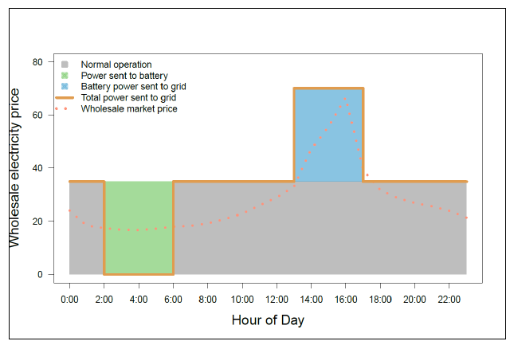
Figure 4. Example of implementing energy storage to increase revenue.⁷
Current nuclear reactor designs are based on light-water technology and are called light-water reactors (LWRs). As can be seen in Figure 5 below, these systems are considered Gen. I-III, and engineers are currently working on the next generation of advanced reactors, which are considered Gen. IV. These Gen. IV reactor designs are based on very different technology from LWRs and designers generally attempt to decrease costs and reactor size as well as increase safety of the systems. The differences between LWRs and the next generation of reactors influences which energy storage options are viable.
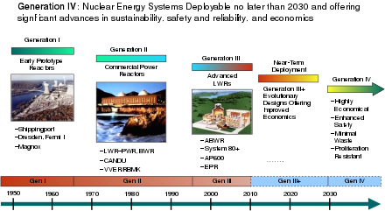
Figure 5. Development of nuclear reactor technology over time.⁸
One major difference between LWRs and next generation reactors is that they operate at significantly different temperatures. As can be seen in Figure 6 below, LWRs tend to operate around ~300C, whereas Molten Salt Reactors (MSRs) can operate at over 700C. Additionally, you can see in Figure 6 that other advanced designs, such as Gas-cooled Fast Reactors (GFRs), Very-High-Temperature Reactors (VHTR), Lead-cooled Fast Reactors, as well as several other next generation designs, all operate at higher temperatures than LWRs. This makes a big difference in which energy storage approaches are most applicable for the different designs. These higher operating temperatures allow more possibilities for energy storage systems in conjunction with these advanced designs.
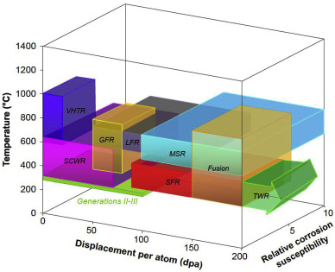
Figure 6. Range of conditions experienced in various nuclear reactor designs.⁹
Next generation reactor designs tend to allow for increased flexibility and additional revenue streams and possibilities when compared with LWRs. For example, the absorbed heat in MSRs can be used as thermal energy for a wide variety of applications. These applications include load following to help the grid deal with intermittent renewable energy; the ability to provide power when not connected to external transmission lines, this is known as black start capability; and it can also be used as heat for industrial processes. These additional capabilities help the economics of implementing nuclear reactors and increases the flexibility of nuclear power and the grid. Having these capabilities combined with a renewable energy source is essentially what a N-R HES is, an example can be seen in Figure 7 below. These types of systems are likely the future of our energy generation systems, and implementing energy storage on a wider scale will help advance our use of renewable energy and these hybrid systems.
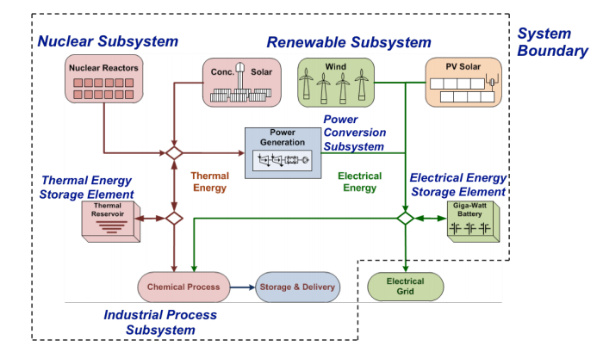
Figure 7. Schematic of a Nuclear-Renewable Hybrid Energy System (N-R HES).²

Overview of Energy Storage Concepts
Energy storage implementing when energy demands are low will help nuclear compete with other energy sources. There are a variety of energy storage concepts that can be used in conjunction with nuclear power, and their overarching categories include: mechanical energy storage systems, chemical energy storage systems, thermal energy storage systems, electrical energy storage systems, and electrochemical energy storage systems. This report will focus on the first three categories but will briefly discuss some of the others. Overall, mechanical energy storage systems and hydrogen production via low temperature electrolysis are fairly well-suited for current nuclear reactor technology. Thermal energy storage systems and hydrogen production via high temperature electrolysis are additional options that are promoted by the next generation of reactor designs.

Mechanical Energy Storage Systems
The three types of mechanical energy storage systems that can be used in conjunction with nuclear power and are discussed in this report are pumped storage hydropower (PSH), compressed air energy storage (CAES), and flywheels. These systems can be used in conjunction with current LWR technology as well as with advanced reactors. These topics are detailed in the following sections.

Pumped Storage Hydropower
Pumped storage hydropower (PSH) is the most prevalent and most developed form of energy storage in the world. Approximately 99% of the energy storage capabilities across the world and 97% in the US are PSH systems.^{7,10} As can be seen in Figure 8 below, PSH systems convert electrical energy to potential energy by pumping water from a lower reservoir to a higher reservoir using electricity during off peak hours, preventing energy from being wasted. During peak hours, water is then allowed to flow back down into the lower reservoir and energy is generated similar to conventional hydropower. Some benefits of PSH facilities are that they offer better ramp rates than natural gas power plants and are black start compatible, which increases the flexibility of the grid.⁷ Additionally, these systems can be used for seasonal energy management and as critical backup reserves due to the large energy storage capacity.⁷ Unfortunately, these systems tend to have significant environmental impacts and can only be implemented if the site meets the geography requirements, such as having some elevation change.^{7,10} Additionally, these systems are larger than any other energy storage technology except compressed-air energy storage. The size of these systems makes it difficult to retire facilities and they can be rather expensive if man-made reservoirs are required to build the system.⁷ These manmade reservoirs can increase carbon emissions due to increased water in certain areas resulting in decaying plants that would not have been decaying otherwise, but these carbon emissions are minimal.⁷ Overall, PSH is well developed, but can have a large environmental impact and can only be implemented at certain sites.
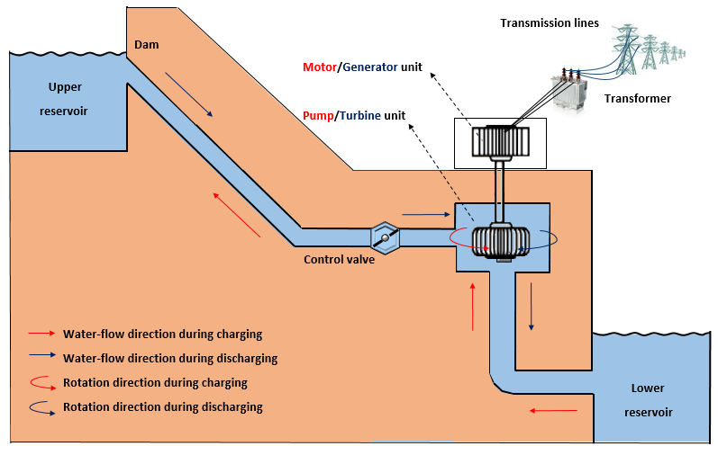
Figure 8. Diagram of a pumped storage hydropower system.¹⁰

Compressed Air Energy Storage
Compressed air energy storage (CAES) is not a particularly prevalent form of energy storage, only two installations exist worldwide, but this technology is fairly well developed.^{7,10} These systems use energy during off-peak times to store energy as potential energy by compressing air and storing it in an underground reservoir, as can be seen in Figure 9 below. During peak demand periods, the compressed air is heated, expanded, and released to a combustor in a gas turbine. The problem with this approach is that it requires natural gas, which increases emissions, but there is work being done to determine better ways to extract the energy without natural gas.^{7,10} These systems offer quick ramp rates but low energy storage and conversion efficiencies when compared with other energy storage approaches.^{7,10} CAES systems also require specific geography requirements to be cost competitive, such as a storage cavern, and tend to have similar sizes to PSH, but they don’t have as significant of an effect on the surface environment as PSH does.^{7,10} Overall, CAES could be a decent option, but work needs to be done to eliminate the use of natural gas and demonstrate these new designs so that the energy is as clean as possible.
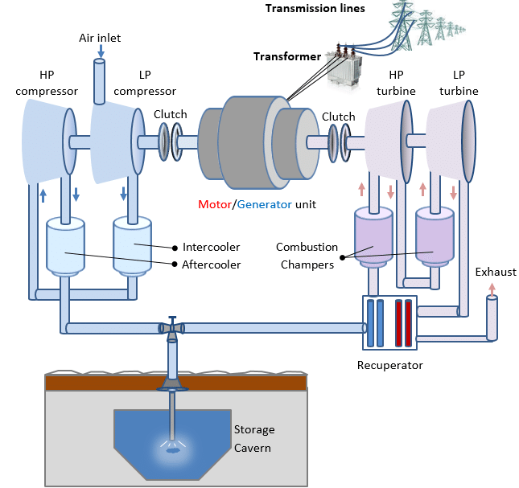
Figure 9. Diagram of a compressed air energy storage system.¹⁰

Flywheels
Flywheel kinetic energy storage systems are not as well developed as CAES and PSH. Unlike CAES and PSH, flywheels store the energy as kinetic energy instead of potential energy. During off peak times, kinetic energy is stored within a spinning rotor that is usually surrounded by vacuum to minimize the frictional losses, as can be seen in Figure 10 below.^{7,10} The energy is then released by applying resistance to the spinning rotor which then acts as a generator.^{7,10} Some benefits of these systems include that they can be used to stabilize the grid, synchronize different energy sources, and are a great option for frequency regulation.⁷ These systems have high charging and discharging rates and are highly efficient, ~90-95%.^{7,10} Flywheels tend to have very low energy capacities but have excellent cycle life and power density compared to other energy storage options.^{7,10} Flywheels are quick responding, durable, modular, and therefore easily scalable.⁷ Additionally, flywheels have minimal environmental impacts. They are small enough to have little to no impact on the areas they are built in and use of these systems does not produce any emissions.^{7,10} Overall, these systems aren’t as well developed as CAES or PSH, but they have minimal environmental impact and are easily scalable to meet changing needs.
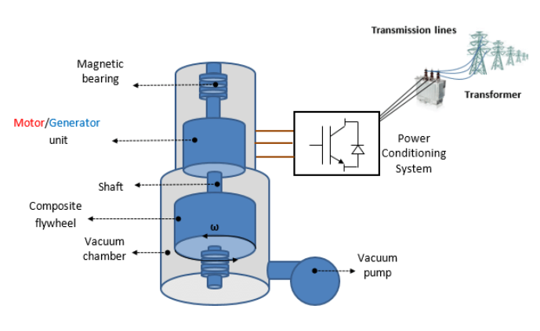
Figure 10. Diagram of a flywheel kinetic energy storage system.¹⁰

Chemical Energy Storage Systems
There are two major types of chemical energy storage systems that can be used in conjunction with nuclear power, hydrogen energy storage and conventional fossil fuels. Since this report emphasizes eliminating fossil fuel use, the only chemical energy storage option that will be discussed is hydrogen energy storage. This topic is detailed in the following section.

Hydrogen Energy Storage
Hydrogen production by electrolysis is an option that can also be used with both current LWR technology as well as advanced reactors, although the best option for this approach is dependent on the reactor technology. During periods of low energy demand, energy from nuclear power plants can be diverted to produce hydrogen. The hydrogen is then stored for future energy needs or can be used for an alternative need (e.g. transportation). Hydrogen is typically produced by the electrolysis of water.¹⁰ This can cost more energy to produce than other methods due to the fact that hydrogen is bonded to other elements, which results in low efficiencies around 20-50%.^{7,10} The most well developed electrolysis technologies generally operate at relatively low temperatures (<100C) and can be used with current nuclear technology by diverting energy for the electrolysis process.⁷ High temperature electrolysis occurs at temperatures around 700-900C, which increases the efficiency of the process, and is currently under development.⁷ This technology is particularly well-suited for use with the next generation of nuclear power plants due to their higher operating temperatures and the potential to supply heat for this process. Hydrogen production via electrolysis is scalable, versatile, compact, and easily integrated into a power plants electrical generation cycle.⁷ Some drawbacks are that this technology currently has high capital costs, issues with durability of system components due to the exposure to hydrogen, and safety concerns particularly with storing and transporting the hydrogen.⁷ Overall, hydrogen production via water electrolysis is a clean energy storage option that could work well with current and future nuclear reactor designs, but this technology must overcome some issues before widespread implementation is feasible.

Thermal Energy Storage Systems
There are many types of thermal energy storage systems that can be used in conjunction with nuclear power. These energy storage systems tend to fall into two categories, sensible thermal energy storage and latent thermal energy storage. The difference between the two is that sensible thermal energy storage systems attempt to prevent a phase change of the storage medium, whereas latent thermal energy storage systems tend to incorporate a phase change of the storage medium.⁷ Thermal energy storage systems are particularly well-suited for use with nuclear energy because they tend to require fewer energy conversions for storage and discharge to the grid.⁷ This allows the potential to be more efficient than some of the other energy storage technologies. The common sensible thermal energy storage systems are underground thermal energy storage systems, hot and cold water storage, and solid media storage. These energy storage systems will not be discussed in detail due to their overlapping similarities with other storage systems. The latent thermal energy storage systems that will be discussed are phase change materials, liquid air, thermochemicals, and molten salts. These topics are detailed in the following sections.

Sensible Thermal Energy Storage
Sensible thermal energy storage systems tend to prevent a phase change of the storage medium.⁷ As a result, these systems tend to use water, rocks, and concrete as storage mediums, which helps minimize environmental impact of these systems.⁷ These storage mediums tend to have somewhat low energy densities, but have reasonable efficiencies.⁷

Latent Thermal Energy Storage
Latent thermal energy storage systems generally incorporate a phase change of the storage medium which allows more energy to be stored per unit mass.⁷ Additionally, the energy stored can be discharged at a consistent temperature due to the incorporation of a phase change. These qualities make latent thermal energy storage particularly useful for integration with power plants and industrial process heat applications. These systems tend to be more expensive than sensible thermal energy storage systems. As expected, a large amount of research has been done on phase change materials, particularly liquid air and molten salts, which are more advanced than some of the other phase change materials under development, as well as the use of thermochemical systems.
The use of some phase change materials is still under development and research is being done to identify new and different phase change materials to be used for specific applications. Some of the materials investigated have phase-transition temperatures that are not useful for the applications they plan to be used for, and so further work needs to be done to identify materials with phase-transition temperatures that are more applicable to a variety of industrial applications.⁷ Some of the materials and advanced equipment used are expensive, so reducing these costs is another area that is being researched.⁷
Liquid air energy storage (LAES) is a phase change material system that is similar to CAES except that the liquid air stores additional energy and is stored above ground in insulated tanks.^{7,10} These systems have the same issues as CAES in that they utilize natural gas for energy extraction, but they also have the potential to use waste heat/cold to prevent the need for natural gas, and this is a major focus of research for these systems.^{7,10} Until new systems are developed and further research is completed, this approach is less green and clean than some of the other approaches.
Molten salt thermal energy storage systems are one of the most developed thermal energy storage approaches.⁷ This is particularly due to work on concentrated solar energy thermal storage systems which has been a major drive to research this area. During off peak times, excess heat is diverted to the storage molten salt, which is excellent for energy storage due to their high boiling points.⁷ These systems are efficient and low cost, and are compatible with current high temperature, high pressure steam turbines.⁷ Some molten salts are hazardous, but others are both non-flammable and non-toxic, making these systems fairly safe.⁷ These systems can be used with the next generation of high temperature nuclear power plants and would be particularly useful for MSRs, an example of which can be seen in Figure 11 below. Previous research has found that use of thermal energy storage in conjunction with a nuclear reactor can enhance the load following capabilities of these systems and provide additional safety margins.¹¹ These systems seem to be of major interest for use with nuclear reactors due to the amount of designs being developed that incorporate this form of energy storage.
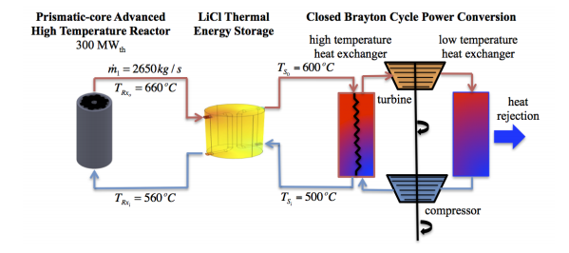
Figure 11. Diagram of a high temperature nuclear reactor in conjunction with a molten salt thermal energy storage system.¹¹
Thermochemical energy storage systems can also be implemented fairly easily with the next generation of nuclear reactor designs. In these systems, energy is used to drive endothermic reactions where the resulting products are stored. To extract the energy, these products are then combined and the reverse, exothermic reaction is initiated. As a result, these systems tend to have superior energy densities, low self-discharge rates, and are a particularly useful for high temperature applications.⁷ Additionally, these systems are very compact and are especially useful for energy transportation due to the high energy density of the chemicals used.⁷ Thermochemical energy storage systems tend to be more cost effective than other energy storage options that are compatible with high temperature applications.⁷ These systems can be used with the next generation reactor designs, particularly high temperature gas cooled reactors where the Brayton cycle is used, an example of how this would be implemented can be seen in Figure 12 below.¹² These types of systems are still under development, but there is a large amount of research being done on these systems due to their usefulness for high temperature applications.
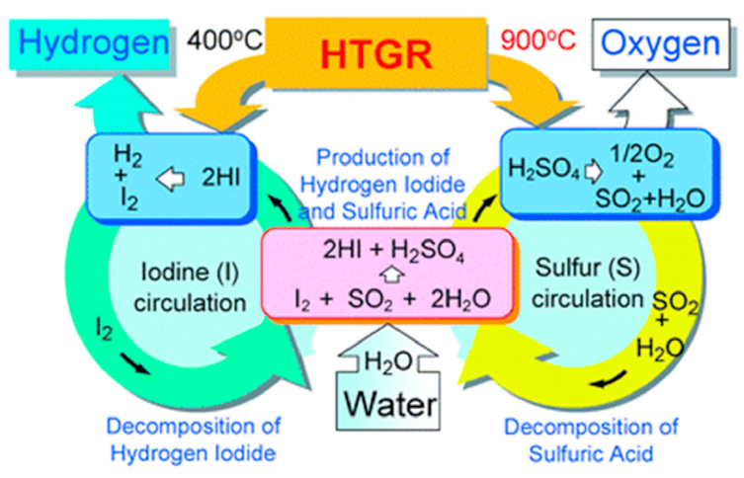
Figure 12. Diagram of a thermochemical thermal energy storage system in conjunction with a high temperature gas-cooled nuclear reactor.¹²

Electrical Energy Storage Systems
The two types of electrical energy storage systems that can be used in conjunction with nuclear power and are briefly discussed in this report are supercapacitors and superconducting magnetic energy storage. These topics are detailed in the following sections.

Supercapacitors
Supercapacitors have several benefits over batteries. They have faster charging and discharging rates and can be cycled more times than batteries.^{7,10} Additionally, supercapacitors have lower environmental impacts than batteries and the materials used are largely available.⁷ The low resistance of supercapacitors results in less energy losses and very high efficiencies, up to 95%.¹⁰ Due to their charging and discharging rates, supercapacitors tend to be best for high power applications.^{7,10} Super capacitors store charge in the electrostatic field that is formed within the electrochemical double layer, as can be seen in Figure 13.¹⁰ Supercapacitors have fast response times and high power densities, but pretty low energy densities due to the low surface area of the electrode, making these systems best for use in conjunction with other energy storage approaches.^{7,10}
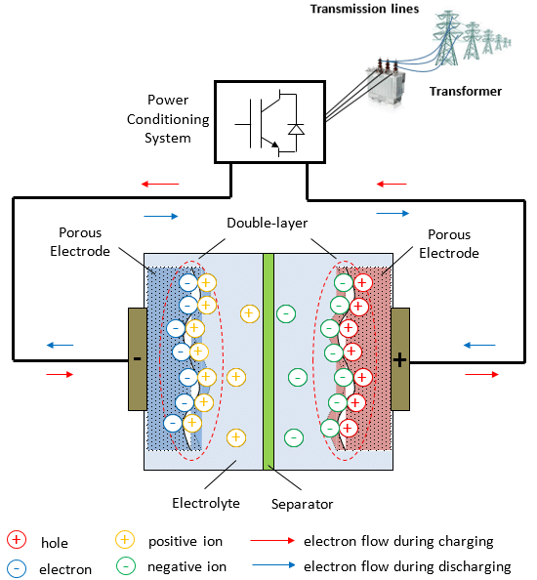
Figure 13. Diagram of a supercapacitor.¹⁰

Superconducting Magnetic Energy Storage
Superconducting magnetic energy storage systems store energy in a magnetic field that is generated by DC current traveling through a superconducting coil, as can be seen in Figure 14.^{7,10} These superconducting coils are cooled to extremely low temperatures to reduce their resistance and allow the coil to be superconducting.^{7,10} The low resistance of the superconducting coils allows the system to store energy for a longer period of time without much energy losses, making these systems very efficient energy storage options, up to 98%.^{7,10} These systems have the similar benefits and issues as superconductors in that they have fast response times and high power densities, but low energy densities, making these systems best to use in conjunction with other energy storage options.⁷ The biggest negative impact of these systems is that the magnetic fields can affect the health of humans and animals in the immediate vicinity of the system.^{7,10} These systems have potential, but are still under development and tend to be used for short-term energy storage.¹⁰
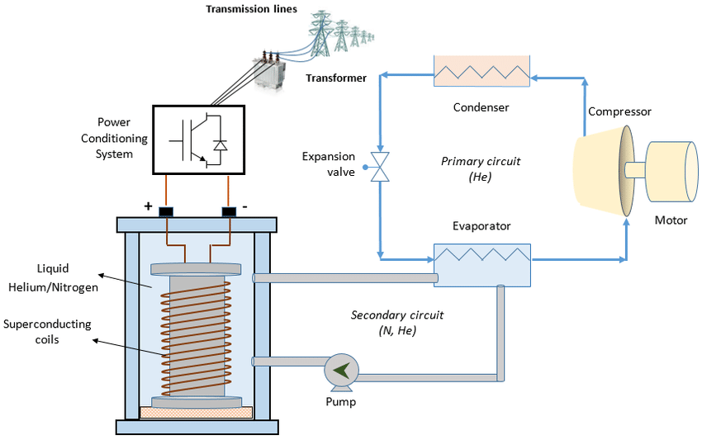
Figure 14. Diagram of a superconducting magnetic energy storage system.¹⁰

Electrochemical Energy Storage Systems
The two types of electrical energy storage systems that can be used in conjunction with nuclear power and are briefly discussed in this report are conventional batteries and flow batteries. These topics are briefly discussed in the following sections due to their widespread use and how well the public is familiar with this technology.
In general, battery technology is fairly well developed which is why batteries are a common energy storage option. Battery lifetimes and cost compared with other energy storage options tend to reduce favorability of utilizing batteries on a large scale, particularly for electrical energy storage.^{7,10} Additionally, current issues with batteries are their environmental impact, safety concerns, and resource depletion.^{7,10}

Conventional Batteries
There is a wide range of conventional batteries available today, including lithium-ion batteries, sodium-sulfur batteries, lead-acid batteries, and nickel-cadmium batteries. The overarching similarity of most conventional batteries is that they tend to store charge in solid electrodes.⁷ Lithium-ion batteries are fairly well developed and tend to be the primary option for consumer energy storage needs, but they still pose safety risks if exposed to oxygen or water.⁷ Sodium-sulfur batteries are thought to be one of the most economically feasible batteries, but they operate at high temperatures and also pose safety risks if exposed to oxygen or water.⁷ Lead-acid batteries are the oldest rechargeable battery technology, but they are fairly large and also have the issue of low cycle life, like most batteries.⁷ Nickel-cadmium batteries have superior cycling characteristics and energy densities, but often require full recharging even after partial discharge due to the memory effect.⁷ All of these batteries are made with hazardous materials that are being depleted and can be difficult to recycle.⁷ The biggest issue for implementing batteries for large-scale energy storage is the costs associated with them, which is not helped by the battery lifetimes.⁷

Flow Batteries
There is a wide range of flow batteries that are under development, including zinc-bromine flow batteries, which are hybrid flow batteries, and vanadium redox flow batteries.⁷ Flow batteries store charge in at least one liquid and tend to store energy in the electrolyte instead of the electrodes.^{7,10} As a result, these batteries can be quickly recharged by replacing the electrolyte used.⁷ These batteries are modular, so their storage capacities can be increased by adding another flow battery to the system.⁷ Additionally, the electrolytes can be stored separately from the battery, which allows for energy to be stored for a particularly long time.⁷ Advantages over conventional batteries include quick response times, long cycle life, full discharging, and their capacity can be increased by increasing the storage tank size.¹⁰ Disadvantages are that they tend to be more expensive and complex than conventional batteries.⁷

Relevant Next Generation Reactor Designs
There are a variety of new designs that implement some of the concepts discussed in this report. NuScale Power is developing a load-following, small modular reactor that is based on LWR technology.¹³ Load following tends to result in operational inefficiencies and reduced revenue, which makes covering capital costs even more difficult. Hopefully this design will be able to overcome the economic issues that comes with implementing load following. This design helps promote increased flexibility of nuclear power designs.
Moltex is developing their stable salt reactor that includes molten salt tanks to store thermal heat.¹³ These salt tanks prevent having to ramp down the reactor during times of low energy usage and helps eliminate some of the issues related to load following. They predict that their system could store energy for around 8 hours but that future designs could store energy for up to 24 hours. This design is implementing thermal energy storage techniques to increase the flexibility of nuclear power and is essentially implementing load following without having to deal with the issues related to load following.
TerraPower’s Molten Chloride Fast Reactor design is intended to not only provide electricity but is also intended to create heat for industrial uses and thermal energy storage.¹³ This design is very flexible due to all of these different revenue streams. Additionally, this design is fairly similar to the hybrid energy systems discussed earlier in this report, but without being in conjunction with some form of renewable energy.
Terrestrial Energy’s Integral Molten Salt Reactor is designed to transport thermal energy to sites up to five miles away.¹³ This design can be used for black start capabilities or renewable load-following. Additionally, this design can be used for chemical production. Terrestrial Energy is also studying the prospects of using heat to produce hydrogen more cleanly and efficiently. This design is extremely flexible and is essentially a N-R HES. Designs like this will make widespread nuclear energy much more economically feasible and will also promote renewable energy sources by helping address intermittency issues that come with implementing renewable energy systems.

Discussion and Conclusions
Costs can be a major issue for implementing nuclear energy on a larger scale. The next generation of nuclear reactor designs are attempting to address these issues in several ways. These next generation nuclear reactors are currently under development but still need to be properly demonstrated before they can be implemented for power generation. According to an MIT Energy Initiative study, any reactor designs that use non-water coolant are fairly likely not to be implemented until at least 2050 due to the steps that need to be taken to get these systems licensed for operation in the US.¹⁴ On the other hand, designs based on LWR technology, such as NuScale Power’s design, will likely be ready for commercialization within the decade.¹⁴ Implementing nuclear power generation in conjunction with energy storage systems, use of heat in industrial processes, and various load following approaches will all help improve the competitiveness and economic feasibility of nuclear energy.
As new reactors are developed and built, we will need to change our energy storage approaches and develop new designs and ways to integrate these systems. The best energy storage options for a specific project are highly dependent on the nuclear reactor type and where it is being built. When determining which energy storage system would be best to use, several energy storage options should be considered to ensure flexibility of the grid and to determine the most useful approach for the specific situation. Researchers at Idaho National Laboratory (INL) have developed a down-selection tool for energy storage systems that could help utilities determine the best energy storage systems based on the reactors that they are building and where they are being built.⁷
Regarding the energy storage systems that have been discussed in the report, flywheels, pumped storage hydropower, hydrogen production, thermochemical processes, and molten salt thermal energy storage are currently the best developed and most applicable approaches to current and future nuclear power designs. This may change as more advanced technology is developed, which is why it is important to consider all available options when designing and building a new nuclear power plant, and the assistance of INL’s down-selection tool will be invaluable for this process. Energy storage systems can help nuclear energy reach its full capabilities in the US and help promote use of renewable energy systems. In conclusion, energy storage and nuclear energy are essential to achieve a carbon-free economy and to increase the flexibility of our grid. We need to implement all carbon-free and low-carbon production and storage options available if we want to achieve this goal and reduce the impact of climate change.

References
1. Nuclear Power in the USA - World Nuclear Association. Available at: https://www.world-nuclear.org/information-library/country-profiles/countries-t-z/usa-nuclear-power.aspx. (Accessed: 18th April 2021)
2. Ruth, M. et al. The Economic Potential of Two Nuclear-Renewable Hybrid Energy Systems The Economic Potential of Two Nuclear-Renewable Hybrid Energy Systems. 1–252 (2016).
3. Nuclear Power Today | Nuclear Energy - World Nuclear Association. Available at: https://www.world-nuclear.org/information-library/current-and-future-generation/nuclear-power-in-the-world-today.aspx. (Accessed: 18th April 2021)
4. Infectious Diseases and How Nuclear Science Can Help | IAEA. Available at: https://www.iaea.org/bulletin/infectious-diseases/infectious-diseases-and-how-nuclear-science-can-help. (Accessed: 18th April 2021)
5. Electricity in the U.S. - U.S. Energy Information Administration (EIA). Available at: https://www.eia.gov/energyexplained/electricity/electricity-in-the-us.php. (Accessed: 18th April 2021)
6. U.S. energy facts explained - consumption and production - U.S. Energy Information Administration (EIA). Available at: https://www.eia.gov/energyexplained/us-energy-facts/. (Accessed: 18th April 2021)
7. Coleman, J. et al. An Evaluation of Energy Storage Options for Nuclear Power. (2017).
8. File:GenIVRoadmap-en.svg - Wikimedia Commons. Available at: https://commons.wikimedia.org/wiki/File:GenIVRoadmap-en.svg. (Accessed: 18th April 2021)
9. Was, G. S., Petti, D., Ukai, S. & Zinkle, S. Materials for future nuclear energy systems. J. Nucl. Mater. 527, 151837 (2019).
10. Poullikkas, A. & Nikolaidis, P. A comparative review of electrical energy storage systems for better sustainability. J. Power Technol. 97, 220–245 (2017).
11. Alameri, S. A. & King, J. C. A coupled nuclear reactor thermal energy storage system for enhanced load following operation. Color. Sch. Mines (2015).
12. Juárez-Martínez, L. C., Espinosa-Paredes, G., Vázquez-Rodríguez, A. & Romero-Paredes, H. Energy optimization of a Sulfur–Iodine thermochemical nuclear hydrogen production cycle. Nucl. Eng. Technol. (2020). doi:10.1016/j.net.2020.12.014
13. Nuclear energy storage? Advanced reactor developers trying to expand nuclear power’s selling points | Utility Dive. Available at: https://www.utilitydive.com/news/nuclear-energy-storage-advanced-reactor-developers-trying-to-expand-nuclea/573570/. (Accessed: 18th April 2021)
14. MIT Energy Initiatives. The Future of Nuclear Energy in a Carbon-Constrained World. MIT Futur. Ser. 1–275 (2018).

